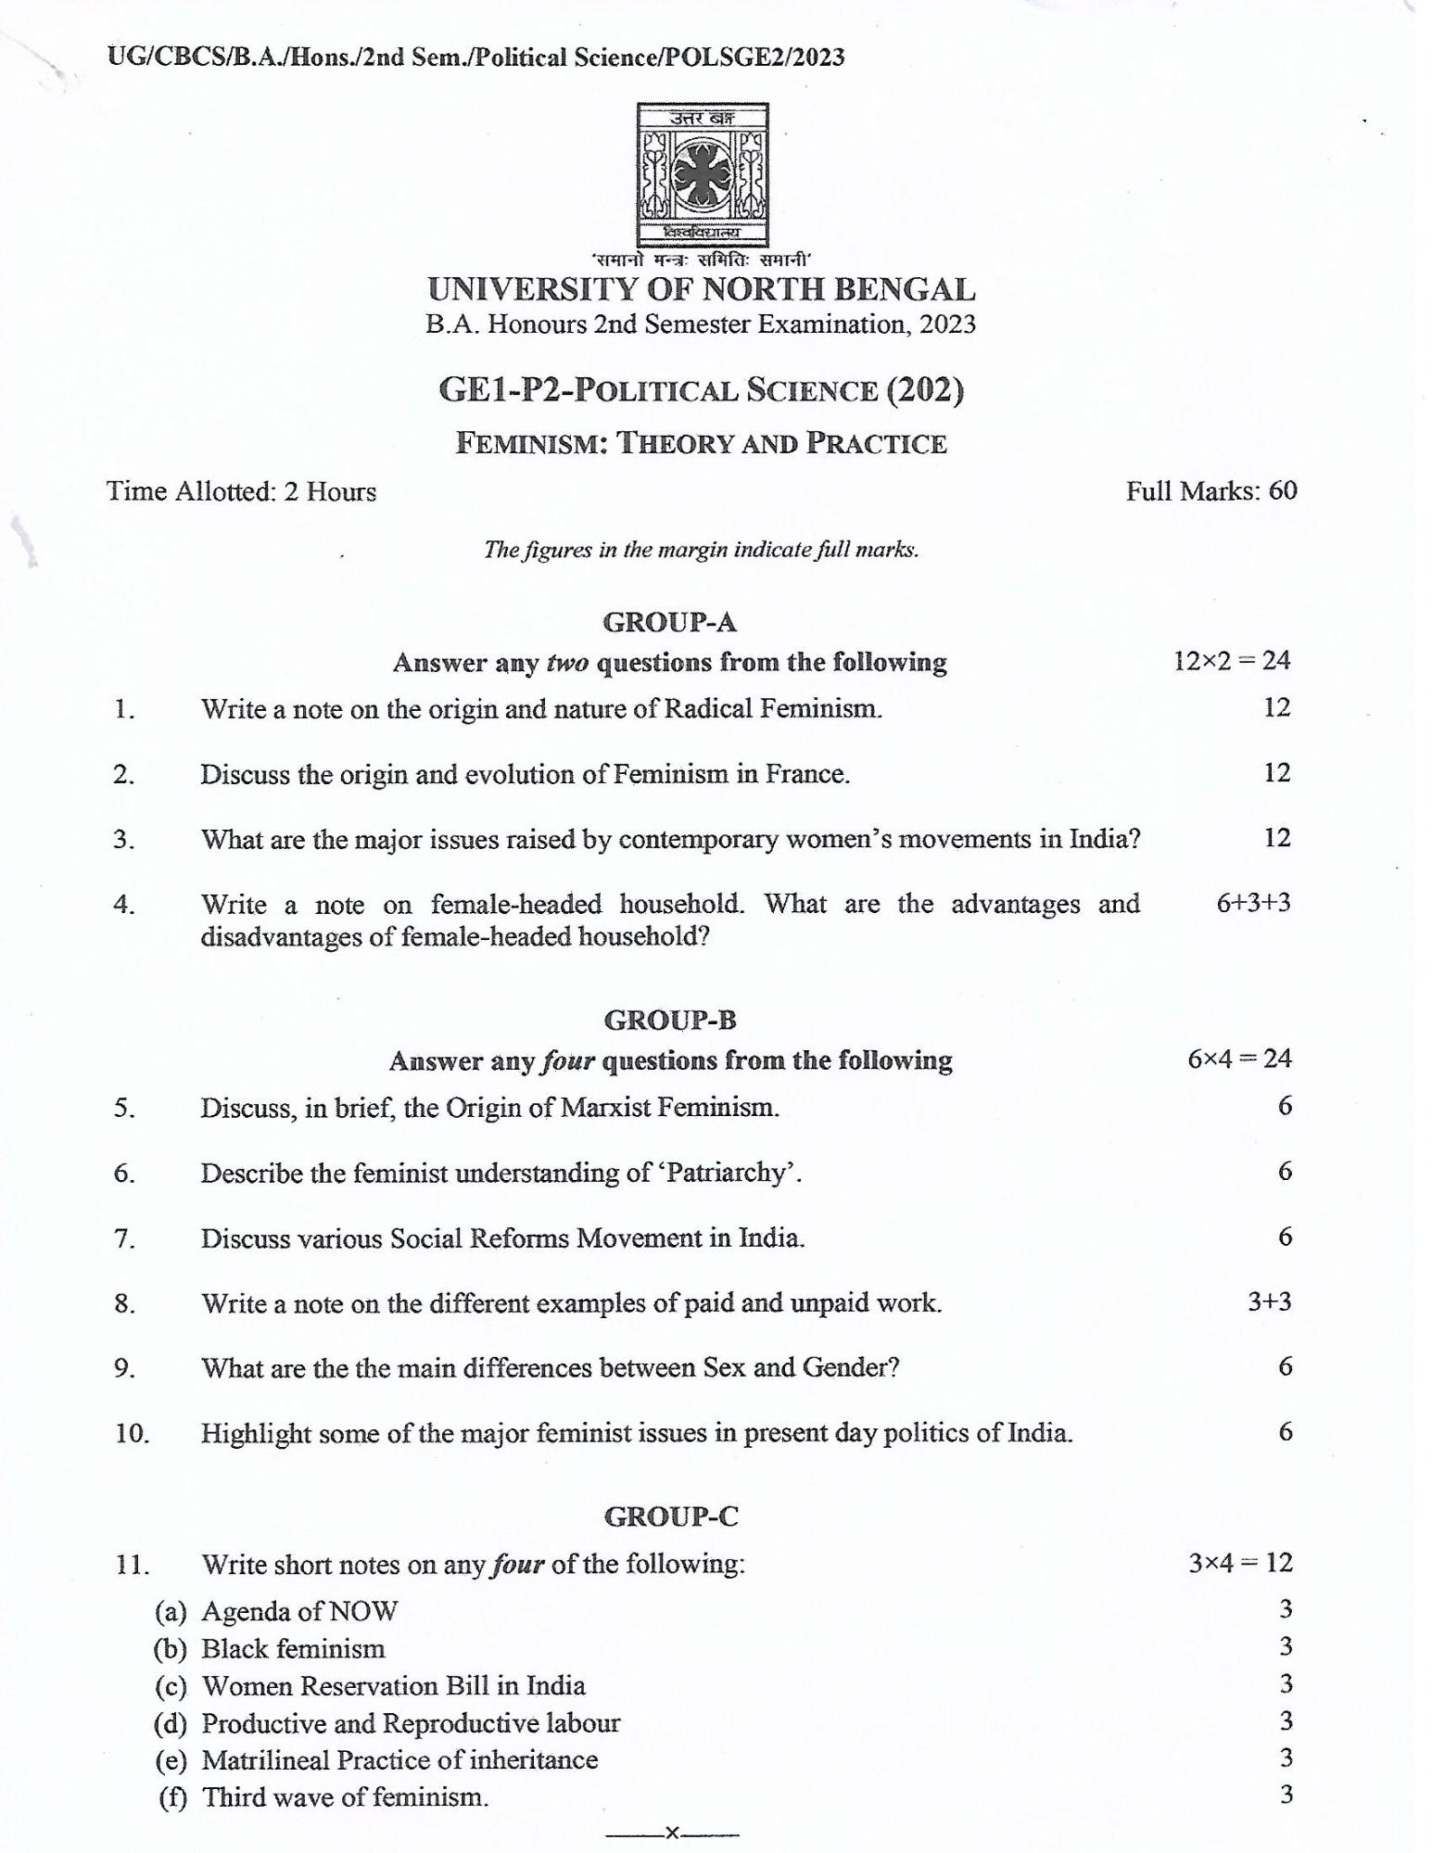
UG/CBCS/B.A./Hons./2nd Sem./Political Science/POLSGE2/2023
Time Allotted: 2 Hours
उत्तर बन
farataener
'समानो मन्त्रः समितिः समानी'
UNIVERSITY OF NORTH BENGAL B.A. Honours 2nd Semester Examination, 2023
GE1-P2-POLITICAL SCIENCE (202)
FEMINISM: THEORY AND PRACTICE
The figures in the margin indicate full marks.
Full Marks: 60
GROUP-A
1.
Answer any two questions from the following Write a note on the origin and nature of Radical Feminism.
12×2 = 24
12
2.
Discuss the origin and evolution of Feminism in France.
12
3.
What are the major issues raised by contemporary women's movements in India?
12
4.
Write a note on female-headed household. What are the advantages and disadvantages of female-headed household?
6+3+3
GROUP-B
Answer any four questions from the following
6×4 = 24
5.
Discuss, in brief, the Origin of Marxist Feminism.
6.
Describe the feminist understanding of ‘Patriarchy'.
7.
Discuss various Social Reforms Movement in India.
6
8.
Write a note on the different examples of paid and unpaid work.
3+3
9.
What are the the main differences between Sex and Gender?
6
10.
Highlight some of the major feminist issues in present day politics of India.
6
GROUP-C
11.
Write short notes on any four of the following:
3×4 = 12
-
(a) Agenda of NOW
(b) Black feminism
(c) Women Reservation Bill in India
(d) Productive and Reproductive labour
(e) Matrilineal Practice of inheritance (f) Third wave of feminism.
3 3 3 3 3 3
X-

